RBES Spring 2016 – 2017 Family Events Calendar
Teachers, Parents, and Students Working Together = Success In School
Vivan Bailey Lending Library  Grades PreK-5  Feb. 16th, Mar. 16th  April 6th, May 4th  During lunchtime  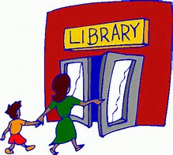  Come eat lunch with your child and visit our lending library. Families can check out games and activities  to take home for reading and math. | Bedtime Math & Reading Night  Grades PreK-5  Feb. 23rd  6:30-8:00 p.m.  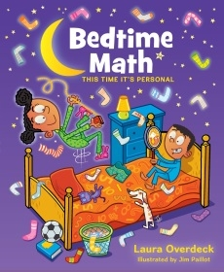  Join us in your pj’s to learn about some fun math and reading activities and apps for your family to use before bed each night. | March 9th & 10th  Student-Led Conferences  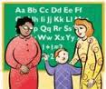  Students are dismissed at 12:50p.m. both days for families to visit the school and meet with their child’s teacher. | A Recipe for Writing Success  Mar. 13th -15th  (School Day times)  Come and visit your child at school and learn how to help your child develop as a writer. | UPCOMING  EVENTS  Feb. 20th & 21st -No School for students  Feb. 24th-PTA Father Daughter Dance  Mar. 1st- Unheard Perspectives Trivia Night 6:30p.m  Mar. 13th-PTA meeting 7p.m.  April 3rd-PTA meeting 7p.m.  April 7th-End of Qtr.3  Early Dismissal 12:50p.m.  April 10th-17th-Spring Break  April 11th-PTA meeting 7p.m.  April 21st-Volunteer Luncheon  April 25th-Report Cards Go Home  May 1st-5th-Teacher Appreciation Week  May-PTA Mother Son Dance-date to be determined  May 9th-PTA meeting 7p.m.  May 12th-Progress Reports Go Home  May 17th-Spring Concert  May 19th-No School for students  May 29th-No School  May 30th–Spring Concert  June 2nd-Field Day  ****************************************** PARCC Testing  June 3rd- Spring Fair  Grades 3-5  Testing will take place at the end of April until the end of May.
Get Ready For Kindergarten  May 31st  4:30-5:30 p.m.  PreK families are invited to come find out what you can do to help prepare your child for school. | 5th Grade  Simulated Congressional Hearings  May 18th  Students present speeches about our country’s government. Families are welcome to attend. | School-wide  Red Carpet Gala  Bridges Show Off Night & Enrichment Fair  May 25th  Come see the wonderful displays of student work throughout RBES. | PreK Learning Parties  PreK students  April 19th, 26th  May 3rd, 10th  6:00-8:00 p.m.  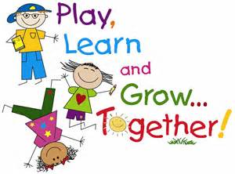  PreK families are invited to participate in  interactive, hands-on activities to help their child learn.

