RBES Spring 2017 – 2018 Family Events Calendar
Teachers, Parents, and Students Working Together = Success In School
Vivian Bailey Lending Library  Grades PreK-5  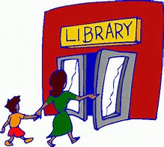  Families can check out games and activities  to take home for reading and math. Call the school to set up an appointment. | Schoolwide Family Math & Literacy Night  What’s your Super Power?  Grades PreK-5  Feb. 15th  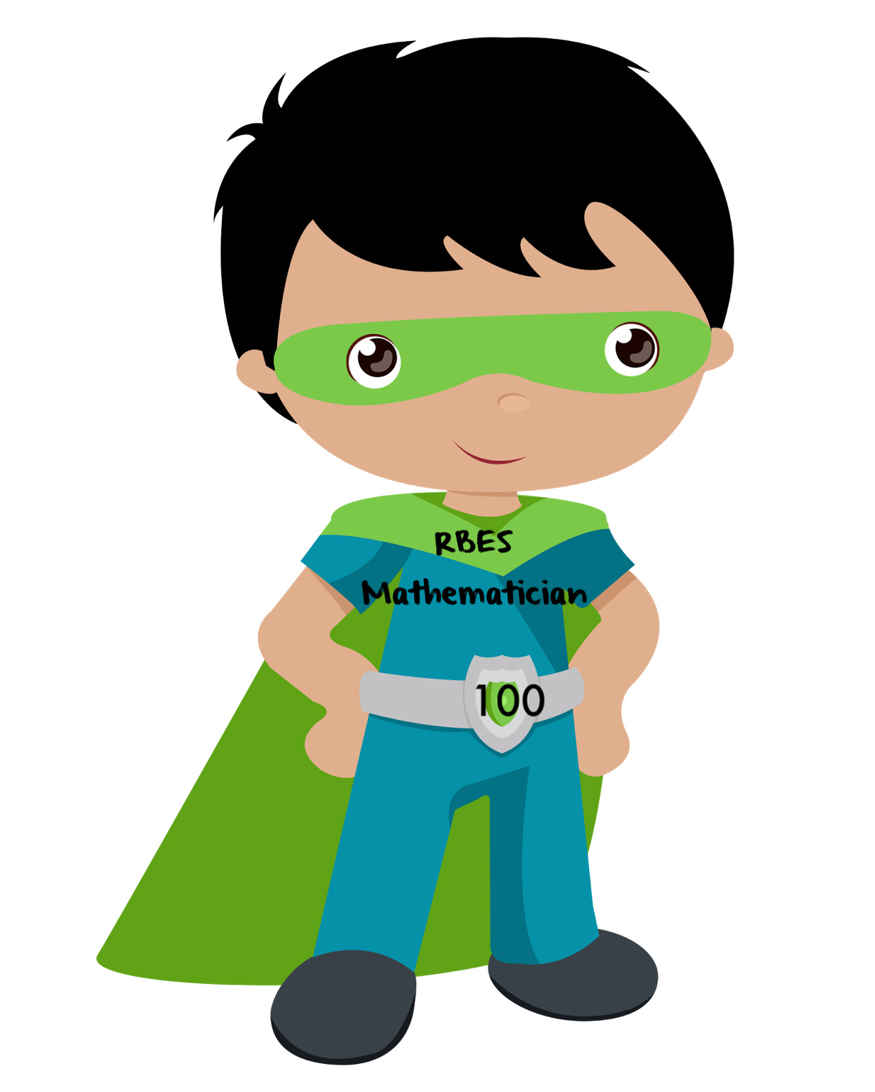  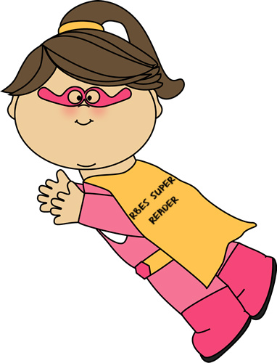  6:30-8:0 p.m.  Come learn how to make math and reading a fun part of kids’ everyday lives. The Book Fair will also be open to visit. | Unheard Perspectives Trivia Night  March 1st  6:30 p.m.  Join us for RBES Black History Trivia Night. Have fun learning with your family and friends! | 3rd Grade  April 12th  6:00-7:30 p.m.  Games! Games! Games!  Third grade families are invited to join us for an evening filled with multiplication and division games! Make family game night fun and educational too! | UPCOMING  EVENTS  Feb. 16th & 19th -No School for students  Feb. 23rd-PTA Father Daughter Dance  Mar. 7th-Progress Reports Go Home  Mar. 12th-PTA meeting 7 p.m.  Mar. 15th-Class & Individual Pictures  Mar. 20th-Family FIT Night 6 p.m.  Mar. 30-Apr. 3rd-Spring Break  April 9th-PTA meeting 7 p.m.  April 13th-End of Qtr.3  Early Dismissal 12:50p.m.  April 13th- PTA Mother Son Dance 6:30 p.m.  April 23rd-Report Cards Go Home  May 1st-5th-Teacher Appreciation Week  May 17th-Progress Reports Go Home  May 18th-Articulation Day/Early Dismissal 12:50 p.m.  May 28th-No School (Memorial Day)  May 30th-Band/Strings/Chorus Concert  June 1st-Field Day  June 2nd- Spring Fair  June 15th-Last Day of School  ***************************************** PARCC Testing  Grades 3-5  Testing will take place at the end of April until the end of May.
2nd Grade  April 24th  6:00-7:30 p.m.  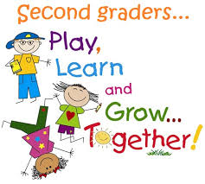  Join the 2nd grade team for a fun night filled with a variety of math, reading, and writing games to play and  take home! | Get Ready for Kindergarten  May 23rd  4:30-5:30 p.m.  PreK families are invited to come find out what you can do to help prepare your child for school. | Get Ready for Middle School  May 24th  6:00-7:30 p.m.  Fifth grade families are invited to come get fun and interesting ideas about preparing your child for middle school.  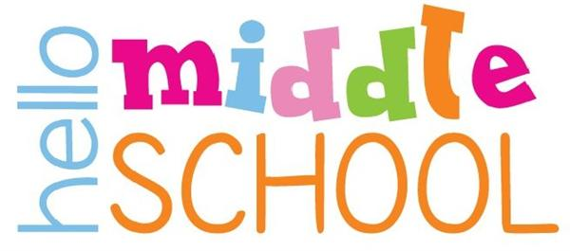 | School-wide  Red Carpet Gala  Bridges Show Off Night & Enrichment Fair  June 6th  Come see the wonderful displays of student work throughout RBES.

