Cut out the activity completed and glue it in your summer passport!

Worked on DreamBox  at least 3 times! | 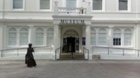  Went to a Museum! | Played a Math Game:  __________________
Kept a writing journal of my summer! | Went to see a movie at the theatre  _________________ | Visited the library at least 3 times!
Worked on a puzzle! | Practiced my math facts! | Rode a bike
Tried a new recipe! | Read a book!  _________________ | Went on a hike!
Community Service | Love video games – pick your favorite and research the designer! | Went to Centennial Park for a Sunset Serranade!  FREE – Wednesdays 7pm  https://www.howardcountymd.gov  /sunsetserenades

Went to a movie on the lake in Columbia  FREE!!  https://www.columbiaassociation.org/  events/lakefront-summer-festival/ | Went to a summer program at the library  https://hclibrary.org/ | 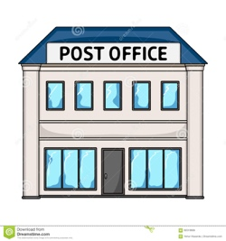  Wrote a letter to someone and mailed it at the post office
Played a card game with someone! | Found a new Math app!! | Played at a playground with a friend
Met a new friend! | Swam in a pool! | Spent time with family
Rode a bus, train, or airplane  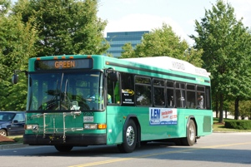 | Tried catching fireflies | Play outside in the rain!!
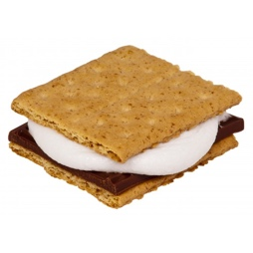  Made Smores | Decorate the sidewalk with chalk | Made paper airplanes!!

